UNDERSTANDING THE MASSACHUSETTS WETLANDS PROTECTION ACT*

BACKGROUND

Wetlands are valuable natural resources. They serve as important habitats for wildlife, purify drinking water supplies and other waters, serve as important spawning areas, and contain food for fish and other aquatic animals. They are especially important for controlling floods.
Activities that involve filling, excavating, or otherwise altering wetlands can impair their many valuable functions. Because state and federal courts have determined that preservation of wetlands serves the public interest, activities that alter wetlands are regulated by law. In Massachusetts, wetlands are protected by the state’s Wetlands Protection Act (administered by local conservation commissions and the Massachusetts Department of Environmental Protection) and the federal Clean Water Act (administered by the U.S. Army Corps of Engineers).
The Rivers Protection Act, passed in 1996, protects riverfront areas in 200 foot zones along rivers. Many cities and towns have adopted local wetland laws that are more restrictive than the State’s Wetland Protection Act. Conservation commissions administer local and state laws governing wetlands. They are also responsible for open space planning, and acquisition and maintenance of land set aside for conservation through direct ownership or through conservation restrictions. Conservation Commissions in Massachusetts have 5 or 7 members who are appointed (rarely elected) volunteers. They may have a paid assistant who does not vote at hearings.

THE MASSACHUSETTS WETLANDS PROTECTION ACT

The Wetlands Protection Act, affects any person proposing to “remove, dredge, fill, or alter any bank, fresh water wetland, coastal wetland, beach, dune, flat, marsh, meadow, or swamp bordering on the ocean or on any estuary (a broad mouth of a river into which the tide flows.), creek, river, stream, pond, or lake, or any land under said waters or any land subject to tidal action, coastal storm flowage, or flooding”. In order to legally work in any wetland, a person must obtain a permit known as an Order of Conditions from the local conservation commission.

* This document is based on “Understanding the Massachusetts Wetlands Protection Act” by The Massachusetts Audubon Society and was adapted for educational purposes. For legal definitions, please see the Wetlands Protection Act and regulations.

8 REASONS HUMANS VALUE WETLANDS:

The act identifies eight main reasons humans value wetlands, known as “statutory interests”
- public/private water supply
- groundwater supply
- flood control
- storm damage prevention
- prevention of pollution
- protection of land containing shellfish
- protection of wildlife habitat
- protection of fisheries

The act states that the conservation commission “shall…impose such conditions as will contribute to the protection of the interests” set forth in the act and requires that all work should be done in agreement with the permit conditions.

This means: People who want to do work in or near wetlands must apply to the conservation commission for permission. Conservation commissions decide whether to approve any applications that will affect wetlands, and may set certain conditions that the applicant must follow, in order to protect wetlands, or minimize the impact on wetland functions.

WHAT AREAS ARE PROTECTED, AND HOW MUCH PROTECTION IS PROVIDED?
The Wetland Protection Act contains specific definitions of the areas it protects and outlines which activities are restricted in those areas.

Different types of wetlands have different degrees of protection under the Act. The greatest protection is provided to wetland areas that border a water body. The water body may be a river or stream, including intermittent (stopping and beginning again) ones, or it may be the ocean, a lake, or a pond. Permanent ponds smaller than 10,000 square feet (approximately a quarter acre) and temporary ponds do not meet the legal definition of “pond” in the regulations (the minimal pond area must have been observed or recorded within the last ten years.)
To be protected as a “bordering vegetated wetland,” the area must border a water body, and at least 50 percent of its vegetation (plants) must consist of wetland plant species. These plants include those named specifically in the Wetlands Protection Act (e.g. buttonbush, red maple, cattail, highbush blueberry, red maple, etc.) as well as other species generally recognized by wetland professionals as wetland indicators (things that are a sign of wetlands.)
Flood areas, determined not by vegetation but by flood elevation, frequency, and magnitude (importance or size), may either border a water body or be isolated. To be protected as “bordering land subject to flooding,” an area must border the ocean or other water body and be inundated (flooded) by the 100-year flood (the flood that has a 1 percent statistical probability of occurring in a given year.), as determined by the Federal Emergency Management Agency for most communities or by a registered professional engineer. An area is protected as “isolated land subject to flooding” if it is an isolated depression that contains a quarter acre-foot of water with an average depth of six or more inches at least once a year. (An acre-foot is 43,560 cubic feet, the amount of water that would flood an area of one acre to a depth of one foot.)
Temporary ponds are protected only if they fall within the 100-year floodplain or if they meet the criteria (rule or standard for making a judgment) for isolated land subject to flooding. Temporary ponds that meet these criteria can receive additional protection if they are certified by the Massachusetts Division of Fisheries and Wildlife as vernal pools (Temporary ponds that fill up with water in the spring as a result of snowmelt, and spring rains. These often dry out during the summer. They are important amphibian habitat.) Concerned citizens can help get vernal pools certified by volunteering to gather the necessary information.

HOW DO THE WETLANDS PROTECTION ACT AND REGULATIONS PROTECT WETLANDS?

With some exceptions, work affecting wetlands cannot be permitted if it endangers wetland functions. Some projects that impact wetland functions can be approved if they fall within categories considered to contribute to the public good, such as coastal navigation, new agriculture; maintenance and improvement of public utilities, roads and bridges, and some kinds of flood control projects. In addition, the conservation commission has the ability to permit wetland filling for a “limited project” such as when a landowner has no alternative access to upland.

THE WETLANDS PERMITTING PROCESS

Any person proposing activities within wetland resource areas or within 100 feet of banks or bordering vegetated wetlands must file with the local conservation commission.

There are two types of filings:

- A Request for a Determination of Applicability (This asks: Do I need a wetland permit? Or are the wetland boundaries correct as I have marked them?)
- Notice of Intent. (I intend to do this work, is it ok with you?)

No work can be done until the conservation commission decides that a wetland permit is not needed, because it will not affect a wetland, or decides that the project may proceed, but the applicant must do the following things. The Order of Conditions states what the applicant must do in order to proceed.

THE DETERMINATION OF APPLICABILITY
The Wetland Protections Act outlines a process that seeks public input. After an applicant files a Request for Determination of Applicability, the conservation commission must hold a public meeting within 21 days. This must be advertised in a local newspaper, at the applicant’s expense, at least 5 days in advance of the meeting. The commission should conduct an on-site inspection before the public meeting and consider information from a variety of sources including wetland maps, the federal flood insurance study, topography and observed water levels.

After reviewing information at the public meeting, the conservation commission must issue a Determination of Applicability within 21 days of receiving the request. (Ordinarily it is issued immediately after the public meeting). If a positive determination is issued the applicant must file a Notice of Intent and receive an Order of Conditions before performing work in the wetland. If the conservation commission finds that the proposal does not affect wetlands, the applicant may proceed with the work after a 10 day appeal period has elapsed.

FILING A NOTICE OF INTENT AND OBTAINING AN ORDER OF CONDITIONS

The Notice of Intent should describe the proposed work with enough detail so that the conservation commission and interested citizens can evaluate impacts on the wetlands and conformance with the rules.

Abutters (people who live next to the wetland and applicant) must be notified about the proposed project.
At the public hearing, information is obtained from the applicant, and questions are asked about the impacts of the project on wetland resource areas, and their important functions. If the commission determines that the plans, and information presented or both are not enough to allow the evaluation of impacts, it may request further information from the applicant and can continue the hearing until it receives this additional information, provided the applicant agrees to the delay. If the applicant refuses, the conservation commission can deny due to insufficient information.
Interested citizens should attend public hearings and ask questions about the impacts of proposed activities on statutory interests (the 8 reasons people value wetlands) and how the developer will mitigate (make less severe) the impacts. Note that ONLY matters pertaining to wetlands are under the rule of the conservation commission. Planning boards make decisions regarding issues of transportation. The board of health rules on issues of public health concerns such as sewage.
Once the commission has reviewed the available information and closed the public hearing, it has an additional twenty-one days within which to permit or deny the project. The commission’s decision is issued in the form of an Order of Conditions, which lists the conditions under which the project may proceed, or permits a project to proceed without modifications. It may deny a project that does not meet the requirements of the wetlands regulations but must explain the reasons for doing so.

APPEALS
Any abutter or 10 citizens of the community where the site exists may appeal the decision. The appeal is sent to the Department of Environmental Protection (DEP) office, with copies sent to the conservation commission and to the applicant. If no appeals are made within ten days, the Order of Conditions is valid.

HOW CAN CITIZENS PROTECT WETLANDS LOCALLY
Citizens can be effective in protecting wetlands by becoming familiar with the requirements of Wetlands Regulations, attending public meetings and public hearings, commenting on projects, and working with their local conservation commission to ensure that Orders of Conditions meet the requirements of the regulations.

FOR FURTHER INFORMATION
Massachusetts Association of Conservation Commissions Massachusetts Department of Environmental Protection
10 Juniper Road, Belmont, MA 02178 1 Winter Street Boston, MA 02108

Vernal Pond Certification:
Massachusetts Natural Heritage Program
Division of Fisheries and Wildlife 508-792-7270

Certified: A Citizen’s Step-by-Step Guide to Protecting Vernal Pools”
Massachusetts Audubon Society
208 South Great Road
Lincoln, MA 01773
Send $9.00 per copy. (Includes postage and handling.)

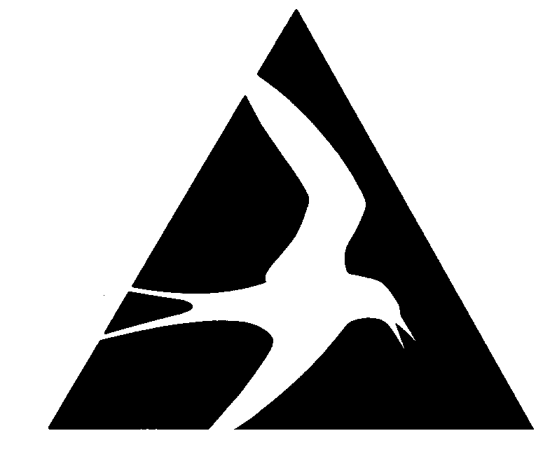

Mass Audubon works to protect the nature of Massachusetts for people and wildlife. Together with more than 100,000 members, we care for 33,000 acres of conservation land, provide educational programs for 200,000 children and adults annually, and advocate for sound environmental policies at local, state, and federal levels. Mass Audubon’s mission and actions have expanded since our beginning in 1896 when our founders set out to stop the slaughter of birds for use on women’s fashions. Today we are the largest conservation organization in New England. Our statewide network of 45 wildlife sanctuaries welcomes visitors of all ages and serves as the base for our conservation, education, and advocacy work. To support these important efforts, call 1-800-AUDUBON (283-8266) or visit www.massaudubon.org.

For more information about coastal wetlands:
Visit the MAS salt marsh science web site at: www.massaudubon.org/saltmarsh

or contact Elizabeth Duff, Education Coordinator at 978-927-1122 ext. 2701 or email lduff@massaudubon.org

Vocabulary Words:
abutters: (in this case) people who live next door to the wetland and applicant.
zoning: The building restrictions in an area of a city or town.
bylaw: 1. Law made by a city or town for the control of its own affairs. 2. A secondary law or rule, not one of the main rules.
ordinance: A rule or law, especially one adopted and enforced by a local authority.
floodplain: An area of land bordering a river and made of sediment carried by the stream and deposited during floods.
estuary: A broad mouth of a river, into which the tide flows.
intermittent: stopping and beginning again. (Streams are often intermittent seasonally, running during the spring as snow melts, drying up in the summer.)
indicators: Things that show or are a sign of.
magnitude: Great importance and effect. Size
inundated: Flooded
criteria: A rule or standard for making a judgment.
vernal pools: Temporary ponds that fill up with water in the spring as a result of snowmelt, and spring rains and then dry up in the summer. They are important amphibian habitat.
mitigate: Make less severe
statutory interests: public interests protected by a law or “statute”, in the case of wetlands, the 8 reasons people value wetlands.
Name _________________________________________ Date_______________________

Read “UNDERSTANDING THE WETLANDS PROTECTION ACT” and answer the following questions:
- What group administers the Wetland Protection Act, and other local and state laws governing wetlands?

- If you want to legally do any work in a wetland, what must a person obtain from the local conservation commission?

- What are 8 main reasons why humans value wetlands?
1 __________________________________________
2 __________________________________________
3 __________________________________________
4__________________________________________
5 __________________________________________
6 __________________________________________
7__________________________________________
8 __________________________________________

- If someone applies to the conservation commission to do work in a wetland, what may the conservation commission do in order to protect or minimize the impact on wetland functions?

___________________________________________________________________________

- Sometimes it is hard to know where a wetland begins and ends. What are examples of plants that only grow in wetlands, and therefore are wetland indicators? _____________________________________________________________________

- Work affecting wetlands cannot be permitted if it endangers wetland functions.

- What kinds of projects may be approved because they contribute to the public good?

___________________________________________________________________________

- Under what circumstances may a landowner be granted permission to do wetland filling?

___________________________________________________________________________

- If work in a wetland is being proposed, ________________ must be notified. These are people who live in the neighborhood, and may have a concern about the proposed work. They may ask questions, and communicate concerns.

- Think about a wetland near you. What wetland functions do you think it supports? Put a star next to the functions in question 3 that you think the wetland near you supports.

- Invasive species may be a threat to wetland functions. Which of the functions in question 3 may be harmed when one plant species takes over a wetland, blocking out all other plants? Explain your answer.
______________________________________________________________________________________________________________________________________________________________________________
Name __________________________________________ Date_______________________

Read “UNDERSTANDING THE WETLANDS PROTECTION ACT” and answer the following questions:

- What group administers the Wetland Protection Act, and other local and state laws governing wetlands?

Conservation Commission

- If you want to legally do any work in a wetland, what must a person obtain from the local conservation commission? A permit (called an Order of Conditions)

- What are 8 main reasons why humans value wetlands?
1 ______private/public water supply 2 _groundwater supply
3 _______flood control _____________ 4_storm damage protection
5 _______prevention of pollution____ 6 _protection of land containing shellfish
7_______protection of wildlife habitat 8 __protection of fisheries

- If someone applies to the conservation commission to do work in a wetland, what may the conservation commission do in order to protect or minimize the impact on wetland functions?

__The conservation commission decides whether to approve applications (and may deny them) and may set certain conditions that the applicant must follow.

- Sometimes it is hard to know where a wetland begins and ends. What are examples of plants that only grow in wetlands, and therefore are wetland indicators? ___buttonbush, red maple, cattail, high bush blueberry, red maple

- Work affecting wetlands cannot be permitted if it endangers wetland functions.
- What kinds of projects may be approved because they contribute to the public good?

__Coastal navigation, new agriculture, maintenance and improvement of public utilities, roads and bridges, some kinds of flood control

- Under what circumstances may a landowner be granted permission to do wetland filling?
______In limited projects such as when a landowner has no alternative access to upland.

- If work in a wetland is being proposed, ___abutters must be notified. These are people who live in the neighborhood, and may have a concern about the proposed work. They may ask questions, and communicate concerns.

8. Think about a wetland near you. What wetland functions do you think it supports? Put a star next to the functions in question 3 that you think the wetland near you supports.

9. Invasive species may be a threat to wetland functions. Which of the functions in question 3 may be most harmed when one plant species takes over a wetland, blocking out all other plants? Explain your answer: Invasives may pose a threat to protection of wetland habitat. An invasive plant may outgrow other plants that provide food and shelter to animals.

